tep 1: Create Action Group (First)
📍 Navigate:
- Go to Azure Portal
- Search Monitor
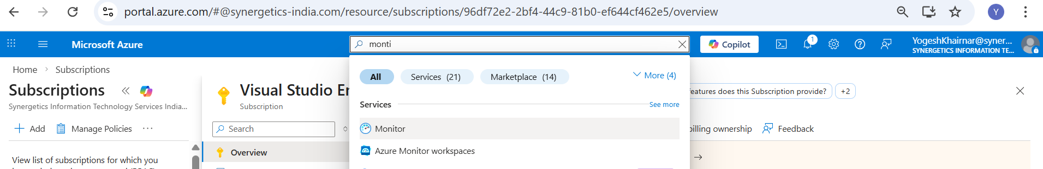
- Click on Alerts > Click on Action Groups
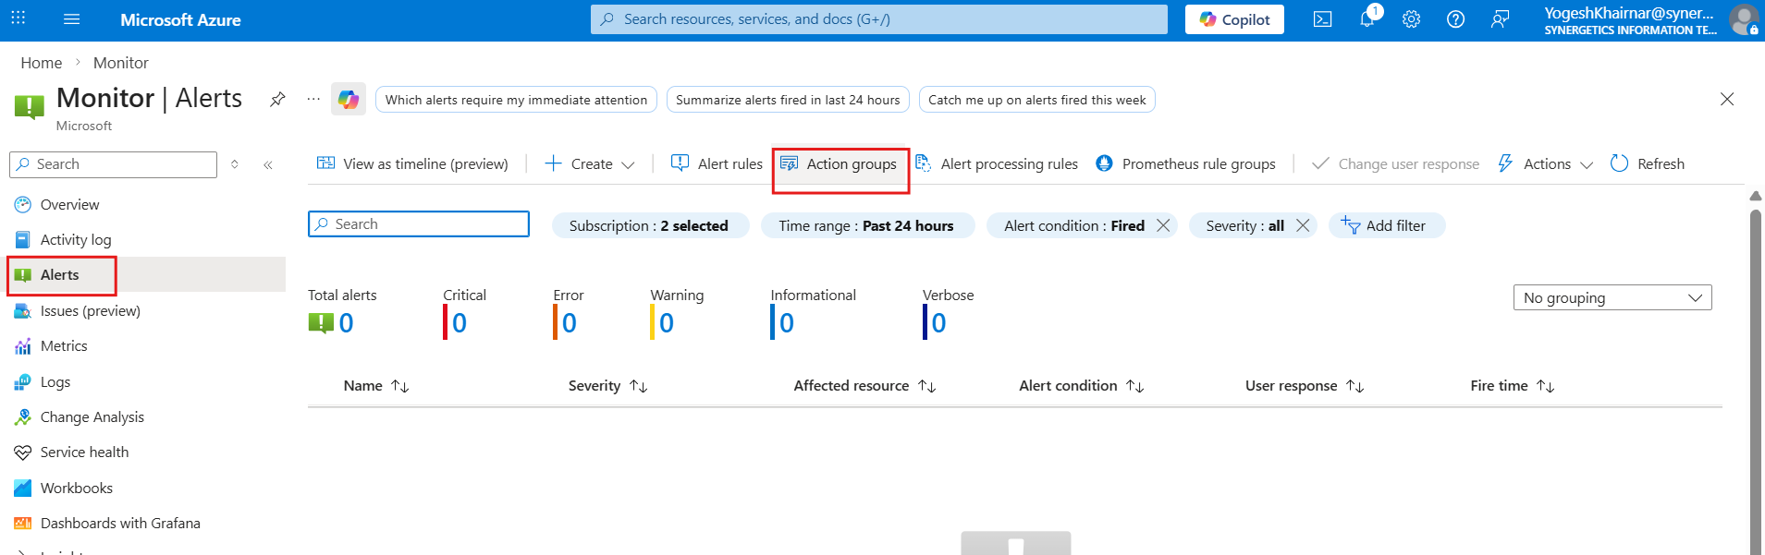

- Click + Create
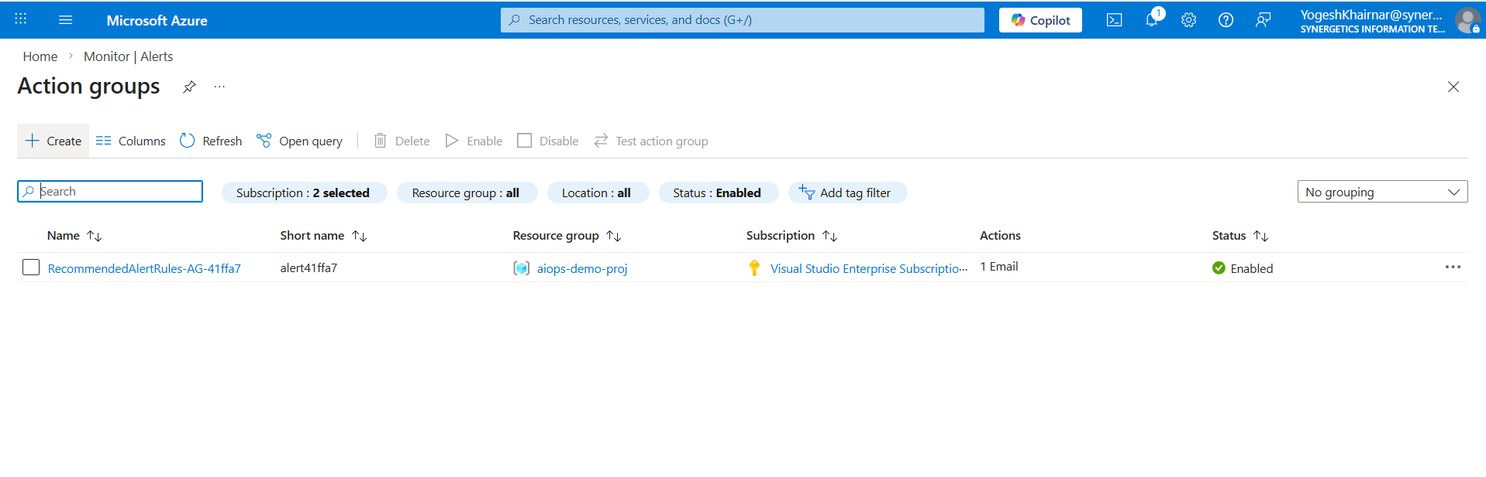

- Select:
  - Subscription → Choose target subscription
  - Resource Group → (Create new or select existing)
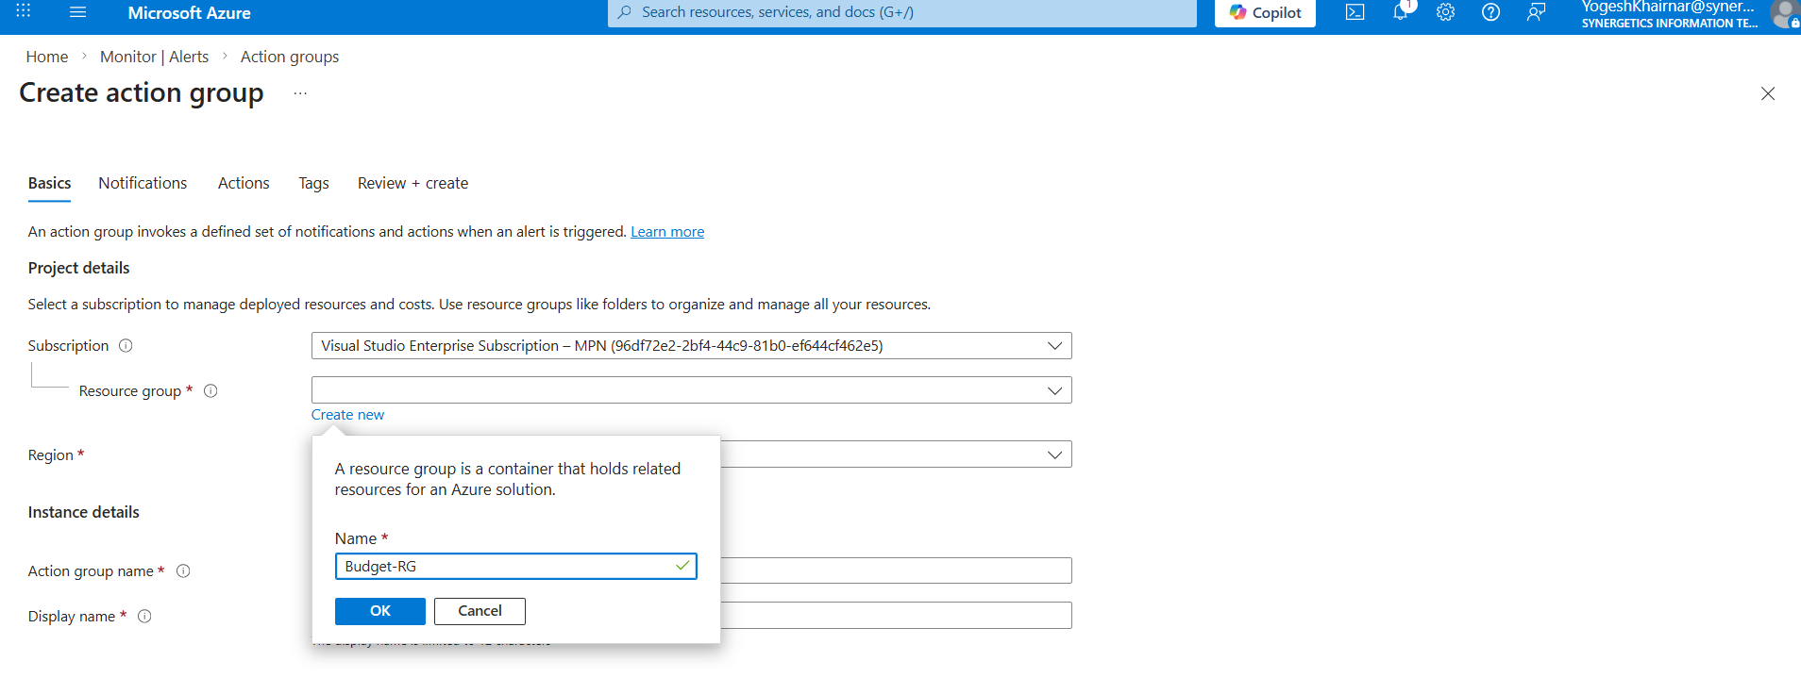
Fill Basics:

- Region : Global
- Action Group Name: Cost-Alert-AG (You can give different name according to your scenerio)
- Display Name: CostAG (You can give different name according to your scenerio)
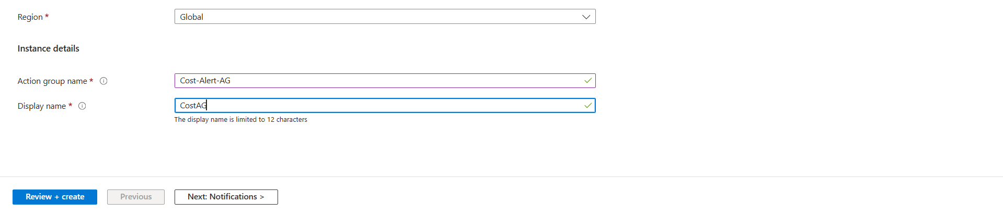

Click Next: Notifications
Add Notification:
- Notification Type → Email/SMS/Push/Voice
- Name → CostAlertEmail
- Click one edit button > check box Email > Enter your email>OK
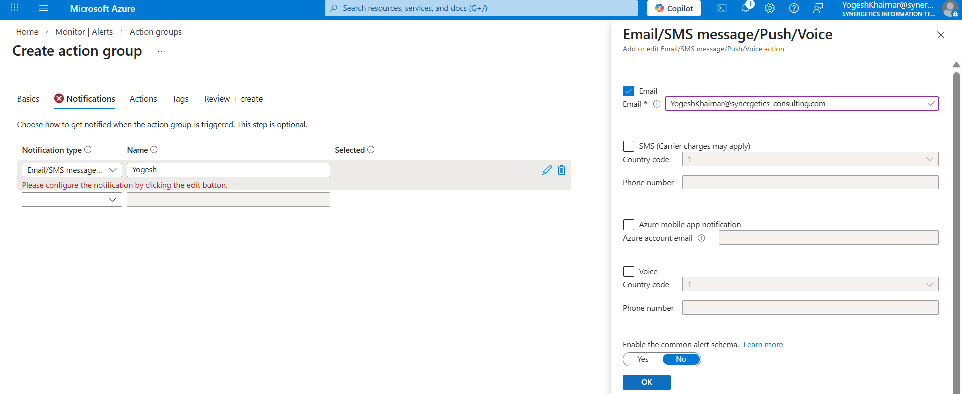
Click Review + Create > Create
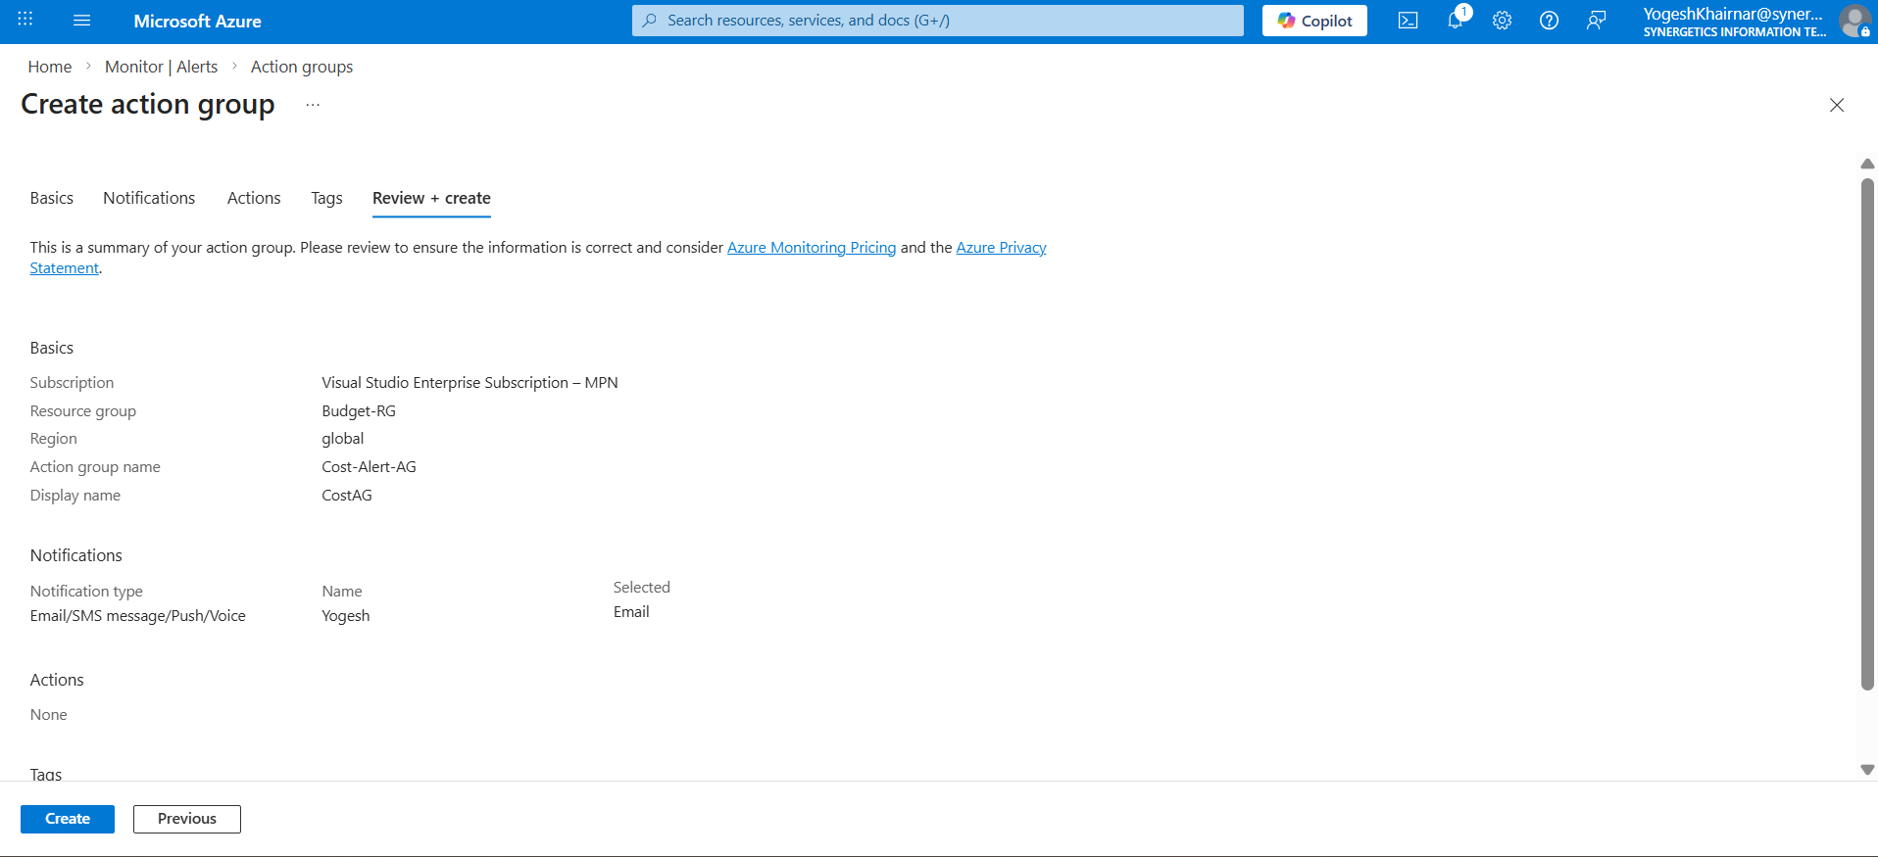
✅ Action Group is ready.

🔹 Step 2: Create Budget (Subscription Level)
📍 Navigate:
- Go to Subscriptions
- Select required Subscription
- Click Cost Management + Billing
- Click Budgets
- Click + Add
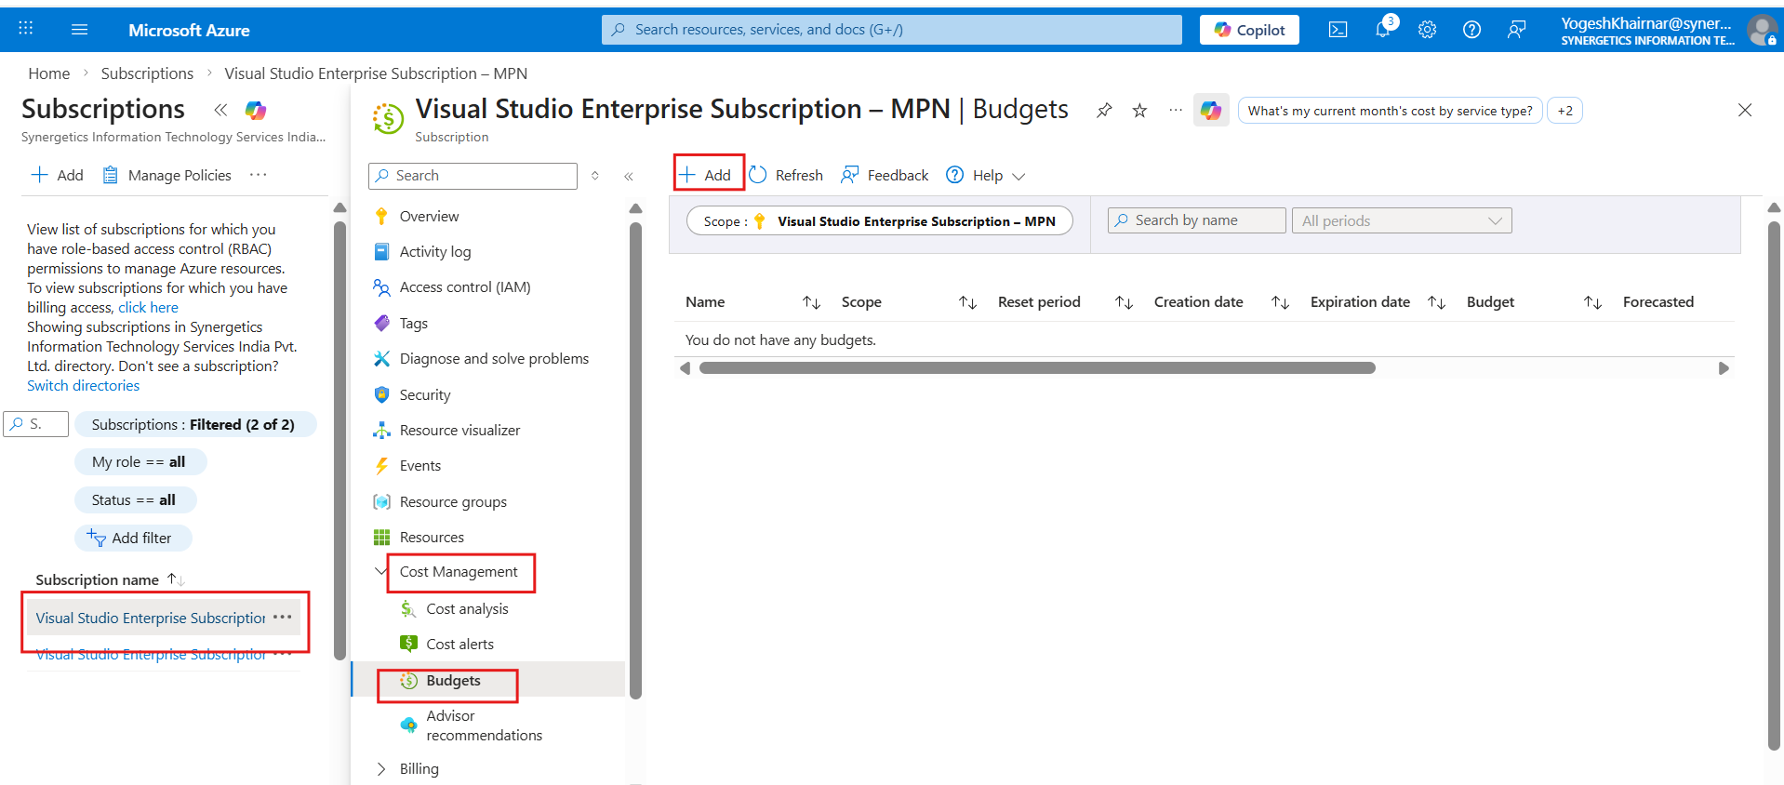

🔹 Step 3: Configure Budget
Basic Details:
- Name → Subscription-Credit-Budget
- Reset Period → Monthly (Recommended)
- Scope → Subscription (Auto-selected)
- Start Date → Current month
- Expiration Date → Optional (or set end of sponsorship)

Set Budget Amount:
- Budget Amount → Based on total available credits
(Example: If $50,000 credit → Set budget = 50,000)
This amount represents the total allowable consumption limit..
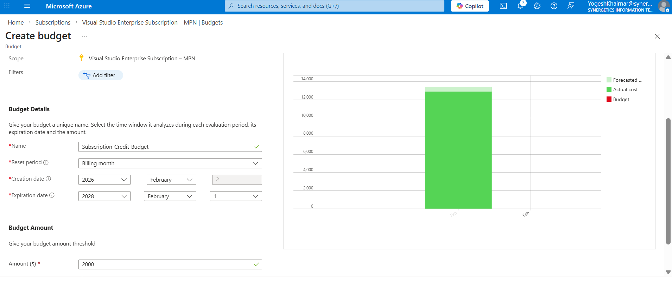
Click Next

🔹 Step 4: Configure Alerts (VERY IMPORTANT)
Create 4 alerts:
Threshold | Type | Action Group
60% | Actual | Select Cost-Alert-AG
70% | Actual | Select Cost-Alert-AG
For each alert:
- Alert Condition → Actual
- Threshold → 60 / 70
- Action Group → Select previously created Action Group
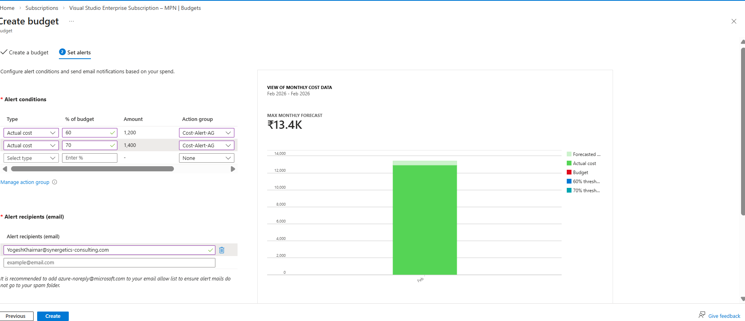
Warning Alerts will be send on the email according to consumption.
Click Create
- Actions that needs to be taken after mentioned alert percentage

- When 60% Alert is Triggered (Early Warning)
Actions:
- Review Cost Analysis (Subscription → Cost Management → Cost Analysis)
- Identify:
  - Top consuming services
  - High-cost resource groups
  - Region-wise cost distribution
- Verify:
  - Any accidental deployment?
  - Any large VM SKU deployed?
- Inform project owner.
Objective: Understand spending trend.

When 60% Alert is Triggered (Optimization Stage)
Immediate Actions:
1. Clean Up Unused Resources
Delete:
- Unattached managed disks
- Old snapshots
- Unused public IPs
- Unused load balancers
- Test resource groups
- Old Azure AI model deployments

2. Stop or Deallocate Idle VMs
- Stop non-production VMs
- Enable auto-shutdown
- Resize large VMs (D8 → D2 if possible)

3. Review Azure AI / OpenAI Usage
If using Azure AI:
- Check token usage
- Reduce model scaling
- Disable unused deployments

Objective: Reduce burn rate immediately.

Deleting Budget or Action Group Resources
- Navigate to Resource Groups in the Azure Portal.
- Select the resource group where the Budget Action Group was created (e.g., Budget-RG).
- Inside the resource group, locate the specific resource (for example, the Action Group).
- Click on the three dots (⋯) on the right side of the resource.
- Select Delete and confirm the deletion.

To Delete All Resources in the Resource Group
If you want to remove all resources at once:
- Go to Resource Groups.
- Select the target resource group (e.g., Budget-RG).
- Click on Delete Resource Group at the top menu.
- Type the resource group name to confirm.
- Click Delete.
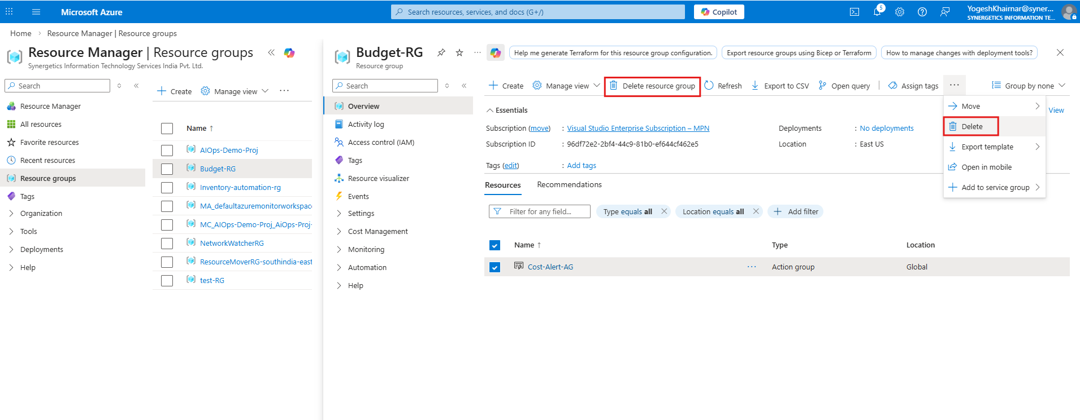
For budget deletion navigate to subscription you have created the budget
subscription > Cost analysis>budget>navigate inside to budget > Click on delete budget.
